Bit Fields in Union and Structure assignments

Mandatory
- You need to store the status of traffic light i.e status of Red, Green, Organge Bulb On/Off status. Define an appropriate data structure for this.
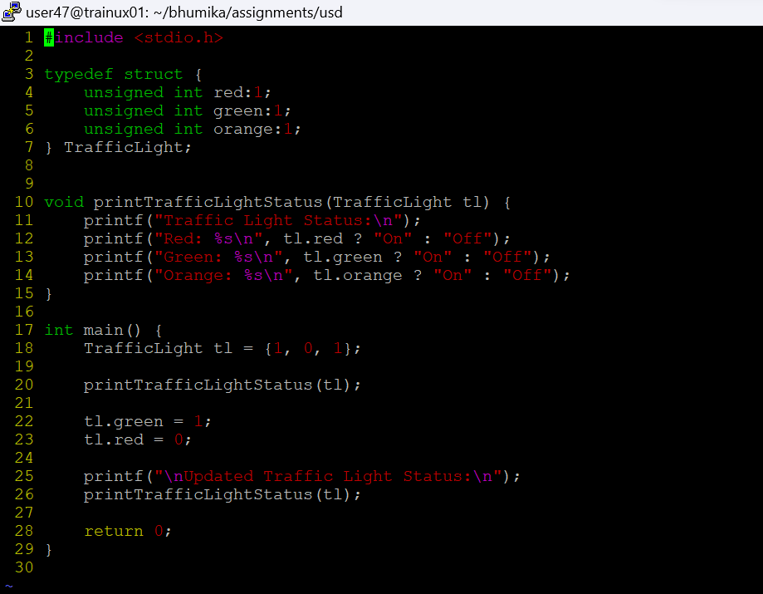
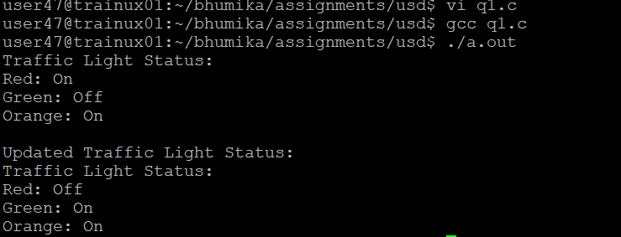
- Define an appropriate data structure to store Person details namely name [max length 100 bytes], age (considering person living for 100 years).
